David L. Suddjian
Biological Consulting Services

801 Monterey Avenue, Capitola, CA 95010
Telephone 831· 479· 9603, email dsuddjian@aol.com

Summary of 2004
Corvid Monitoring Surveys

In The Santa Cruz Mountains

Prepared for

Command Oil Spill Trustee Council

Prepared by

David L. Suddjian
Biological Consulting Services
801 Monterey Ave., Capitola, CA 95010

May 5, 2005

INTRODUCTION

In 2002 a preliminary study in Big Basin Redwoods State Park, Portola Redwoods State Park, Butano State Park, and San Mateo County Memorial Park (Figure 1) was conducted to compare relative abundance of corvids in areas of high human use with those well removed from areas of high use (D. Suddjian unpubl. data). In 2003 the Command Oil Spill Trustee Council (COSTC) initiated a corvid monitoring program in the same four parks that was patterned closely after Suddjian’s 2002 effort (Suddjian 2004). The COSTC study was to assist the Council in restoration planning for potential projects benefiting the Marbled Murrelet (Brachyramphus marmoratus), including corvid management. This report presents the results of corvid monitoring surveys conducted in 2004.

Corvids are among the most significant predators on eggs and chicks of marbled murrelets (Nelson 1997). Both Steller’s Jay (Cyanocitta stelleri) and Common Raven (Corvus corax) have been documented to prey on murrelet eggs or chicks in the Santa Cruz Mountains (Singer et al. 1991, Suddjian 2003a, 2003b). The Steller’s Jay has apparently always been a prominent member of the avian community in old growth forests in this region. In contrast, Common Ravens are relatively new in those forests, and have only become numerous in recent decades (Figure 2; Kelly et al. 2002). Both species are attracted to campgrounds and other areas of parks with high human use, where human food is often readily available. Consequently, previous studies and general observations in the Santa Cruz Mountains have typically found both corvids to be much more numerous at campgrounds than away from campgrounds.

This study compares corvid populations in murrelet nesting habitat within campgrounds (treatment areas) to corvid populations in such habitat in areas located >300 meters from campgrounds (control areas). It also provides a baseline from which to judge future changes in numbers related to corvid management projects.

Methods

Study Design

The preliminary study conducted in 2002 sampled corvids in nine treatment areas and 19 control areas (D. Suddjian unpublished data). The monitoring program initiated by COSTC in 2003 established and surveyed one or more treatment and control areas in each park in 2003, except at Memorial, where no suitable control areas were identified (Table 1, and Figures 3-6). All of the treatment and control areas selected for the COSTC study overlapped entirely or partially with areas surveyed by Suddjian in 2002. Surveys in 2004 sampled seven treatment areas and 12 control areas

All survey sites are in coast redwood (Sequoia sempervirens) forest known to support use by Marbled Murrelets, with nesting known or suspected to occur either in or immediately adjacent to the survey area. They range in size from 3.2 to 15.7 hectares (Table 1). Control areas are located a minimum of 300 meters from any campground, picnic area, or residential community, and are located along roads or trails to facilitate access. Treatment areas include standard campgrounds and their immediate surroundings. Group campgrounds were excluded because they are irregularly occupied, and they were often smaller than a minimum size criterion of 3.0 hectares. Two large picnic areas (Opal Creek in Big Basin and Tan Oak Flat in Memorial) were sampled in 2003, but were excluded from the study in 2004 for reasons discussed in Suddjian (2004).

Description of Survey Areas

General Patterns Of Human Use

The campgrounds are used continuously thought the survey period of June to August, although occupancy varies daily and through the season. Occupancy is typically 100% on weekends, but often considerably less on weekdays, and is generally greater in July and August than in June. Campground occupancy during the surveys in 2004 ranged from 11% to 87% (Table 2). Average occupancy for each campground in 2004 was reduced by 5-41% from occupancy in 2003, except at Ben Reis in Butano where average occupancy increased by 21% (Table 2). Half to two thirds of the main campground at Portola was closed to campers on three of the four survey days there.

Human foods are continually available to corvids at occupied campgrounds. Food is occasionally (but regularly) offered directly to wildlife by campers, but is also widely available as discarded or fallen scraps or fragments, garbage left at camp sites, food fragments stuck on grills at fire rings, and at water spigots where dishes are rinsed. Food left unattended during the day or improperly stored at night is commonly plundered by wildlife. Additionally, in some parks food is readily available at trash receptacles that permit animal access, spillage by animals, or are too full to close properly.

Human activity in the control areas is mostly limited to hiking, with no established picnic sites. No people other than the surveyor were evident during any of the morning surveys in control areas in 2003 or 2004.

Big Basin Redwoods State Park

Treatment areas are Blooms Creek Campground (55 sites), Sempervirens Campground (31 sites), Huckleberry Campground (71 sites), and Wastahi Campground (27 sites) (Table 1, Figure 3). Two control areas are located along the upper reach of Opal Creek, and four are along Gazos Creek Escape Road west of Opal Creek (Table 1, Figure 3).

Campgrounds had trash dumpsters with plastic lids, and a small number of metal trashcans with hinged wooden lids. The margins of the plastic and wooden lids on the dumpsters were often chewed by squirrels, enabling them to enter and forage, occasionally dragging trash and food out of the dumpster. Rusted holes in some dumpsters permitted the same access to garbage. The lids on the dumpsters and trashcans were usually closed, but rarely were left open, and occasionally the lid of overly full dumpster could not be closed, permitting birds and other animals to reach its contents.

Portola Redwoods State Park

The treatment area is the main campground, referred to here as Portola Campground (53 sites; Table 1, Figure 4). The control areas are along Peters Creek north of the campground, and in two areas along the Iverson Trail (Table 1, Figure 4).

The campgrounds and picnic areas at Portola have metal trash bins with animal proof lids. No animal access to the cans or spillage around the garbage receptacles was observed in 2004.

Butano State Park

The treatment area is the Ben Ries Campground (61 sites; Table 1, Figure 5). The control areas are along the Butano Service Road extending northeast from the campground, Goat Hill Trial, and Doe Ridge Trail (Table 1, Figure 5).

The campground at Butano had metal trashcans with hinged wooden lids, placed within a wooden receptacle. The lids were heavy enough to prevent animal entry, although the edges of some had been partially chewed. No animal access to the cans or spillage around the cans was observed in 2004, although unprotected food left in the open beds of campers’ pick-up trucks was plundered and left scattered by raccoons (Procyon lotor).

San Mateo Memorial County Park

The treatment area is the Sequoia Flat Campground (104 sites) (Table 1, Figure 6). No control areas with suitable habitat and sufficient distance from areas of high human use were identified, so control areas for this park were located in Big Basin instead (four areas along Gazos Creek Escape Road, Figure 3).

The campground at Memorial had numerous open metal trashcans with no lids, and a small number of metal dumpsters with plastic lids. Animal access was commonly observed. Trashcans were tipped over and spilled by raccoons and other mammals, and mammals entered the cans and carried garbage out of them onto the ground.

CoRvid Survey Methods

Each site was surveyed using the total area search method (Ralph et al. 1993). The search area at treatment areas included the entire area of campsites and extended outward 50 meters from the edge of the camp boundary. Control areas were established along roads and trails, and the search area extended outward for 50 meters from the center of the road or trail. Thus, the control areas were equivalent to 100-meter wide strip transects in which the total area searches were conducted. Fifty meters was selected as the outside distance to insure the best chance of visual detection of perched, silent birds. Vegetation obscured views too significantly beyond 50 meters. Movement off the road or trail was avoided in control areas to minimize noise made by the surveyor.

David Suddjian conducted all the surveys. Surveys were done by walking slowly through the survey site and pausing often for brief periods, listening for vocalizations and making visual scans to detect corvids. Although Luginbuhl et al. (2001) found that broadcasting taped calls enhanced detections of ravens, this method was not used in this study to avoid disturbance of campers and distraction to the surveyor when campers would inquire about the broadcast calls. Furthermore, the taped calls might attract ravens into the survey areas from outside the boundary during the survey.

Each jay and raven was recorded, indicating its age if known. Aging of ravens was straightforward though the season due to the status of molt of adults, feather wear, vocalizations, and the presence of a pale gape on the juveniles. Aging of jays was easy in June and most of July (using plumage pattern, begging behavior and vocalizations, and the pale gape of the juveniles), but it became more difficult in late July and August, when the juveniles more closely resembled adults and begging activity declined. Behavior of jays and ravens was recorded in notes, particularly as it related to foraging.

Other information recorded for each survey included date, start and end times, weather conditions, number of occupied campsites, number of opportunities to access human food (i.e., spilled trash, unattended food, campers feeding wildlife), and details of foods consumed by corvids.

Survey Frequency and Timing

Four surveys were conducted at each site, with one survey in June, two in July, and one in August. Survey dates in 2004 for each site are given on Table 3. Each site was surveyed only once per day, but often more than one site was surveyed on the same morning. Campgrounds were only surveyed on weekdays. An effort was made to sample each site on dates close to those when it was sampled in 2003.

Each survey occurred in a window beginning 35 minutes after sunrise and extending for up to four hours after sunrise. The rationale for selection of this window of time for the surveys was described in Suddjian (2004). The time required to cover each survey area varied with the size of the area, but the average rate of coverage was 3.1 minute per ha (± 0.6 minute). The time expended in each area was kept fairly consistent over the four replications.

Analyses

Analyses comparing treatment and control areas used only the maximum number of corvids detected on any of the four surveys of each area (Luginbuhl et al. 2001), although average counts are also presented in the tables. No effort was made to distinguish among ages of corvids for these analyses. Values of p < 0.05 were considered statistically significant, while values 0.1> p > 0.5 were considered marginally significant.

Some comparisons are made to the results of the preliminary study of 2002 (D. Suddjian unpubl. data) for all sites pooled together, as the sites were either the same as those of the COSTC-sponsored surveys, or overlapped with them broadly, and the surveys methods were the same.

Results

Steller’s Jay

Survey results and statistical comparisons for each park in 2004 are given on Tables 4 and 5. Steller’s Jays were recorded in all survey areas, and were detected on all 28 surveys in treatment areas, and 90% of 48 surveys in control areas (Table 4). They were particularly ubiquitous in treatment areas, where overall they were nine times more numerous than in control areas, with the difference being highly significant (Table 5). The higher numbers in treatment areas compared to controls was significant for each park (Table 5).

Steller’s Jays showed a net decrease in abundance from 2003 to 2004, with indices dropping by 34% in treatment areas and 20% in control areas when data from all the parks were pooled (Table 8, Figure 7). However, the change was not statistically significant (t = 1.33, p = 0.104). Abundance decreased between years in treatment areas in Big Basin (-49%), Portola (-25%) and Memorial (-24%), but remained nearly the same at Butano (+2%) (Figure 8). Percent change in control areas was also large in three of the four parks, but not biologically significant due to the small number of individuals involved.

As in 2003, jay density in 2004 was positively correlated with the number of occupied campsites in a campground (r = 0.33, p = 0.041; Figure 9), although the correlation was less strong than in 2003 (cf r = 0.53 and p = 0.002 in 2003; Suddjian 2004). As in 2003, Sequoia Flat Campground at Memorial, the largest campground in this study, had the highest density of jays (maximum raw count of 136 jays on August 25), and exceeded peak jay densities in the other treatment areas by two to five times (Table 4). This was presumably due to Sequoia Flat’s large size, as well as the numerous open trashcans that permitted easy foraging by jays.

Jay behavior and interactions with people were similar to those observed in 2003 and described in Suddjian (2004). Jays were observed taking advantage of spilled garbage, stealing unattended food in camps, and being fed directly by campers. Jays were frequently seen inspecting occupied campsites for food, and were very quick to capitalize on an opportunity to steal unattended food, or to search for food in just-vacated sites. Two places where jays consistently sought and found scraps of food were at the grills of campsite fire rings, and at campground water spigots where campers rinse their dishes. Human foods taken by jays during the surveys were similar to those mentioned in Suddjian (2004).

Jay productivity in 2004 (as measured by the percentage of juveniles on the surveys) was on average similar to that of 2003. It was higher than in 2003 at Portola, Butano and Memorial, but lower in Big Basin. The timing of fledging was somewhat earlier than in 2003, which was considered to be an unusually late year (Suddjian 2004). The seasonal increase in juvenile jays in the campgrounds was statistically significant (r = 0.81, p <0.0001; Figure 10), but no significant increase was evident in the control areas. Very few juvenile jays were seen in control areas, but that may have been an artifact of small samples of birds in those areas

Similarly, jay density increased over the season at all campgrounds (Figure 11), but the trend was only marginally significant (r = 0.31, p = 0.054), contrasting with a more pronounced seasonal increase in 2003 (cf r = 0.62, p = 0.0002, Suddjian 2004). As in 2003, densities in control areas in 2004 showed no consistent pattern over the season (Table 4).

Common Raven

Survey results and statistical comparisons for each park are given on Tables 6 and 7.
Common ravens were recorded in all seven of the treatment areas in 2004, where they were detected on 96% of the 28 surveys (Table 6). In contrast, they were detected at just 48% of the 12 control areas, and on only 19% of 48 surveys (Table 6). Raven numbers in treatment areas exceeded those in control areas by over seven times when the data from all sites was pooled together (Table 7). Taken individually, the difference between the two areas was also significant for each park (Table 7).

Common Ravens showed a significant increase in abundance from 2003 to 2004 in the treatment areas (data from all the parks pooled, t = 1.92, p = 04), but abundance in control areas decreased slightly (Table 8, Figure 12). Abundance increased between years in treatment areas in each park individually, but changes were mixed in the control areas of each park (Figure 13). Even though the changes between years in each park were statistically significant (Table 7), in all situations the changes in absolute numbers of individuals were small, and no large groups were encountered in 2004. Ravens were generally uncommon. Most surveys recorded only one or two adults, and rarely three or four adults. Most of the change between years was attributable to a greater number of juvenile ravens in 2004.

Unlike the jay, raven density did not increase consistently over the season among the sites (Table 6). Most sites had one pair of adults that was regularly present, and their offspring, which in some cases had already fledged by the time of the first surveys in June. Productivity in 2004 was greater than in 2003 (a notably poor year in the study area; Suddjian 2004), but was somewhat less than in 2002 (Suddjian unpubl. data), and this is thought to be the main factor leading to the changes in abundance between years. In 2004 most pairs that nested successfully in the study area fledged three or four young. A nest attempt at Huckleberry Campground in Big Basin apparently failed by late June, and it was unclear if the pair at Blooms Creek Campground even attempted to nest. Extensive fieldwork in Butano indicated that the family group seen at Ben Ries Campground in late July had come from a nest well away from the camp. Daily movements by adults or families with juveniles to visit campgrounds were evident in all of the other parks, too. Night roosts were characteristically located outside of campgrounds.

Raven behavior and interactions with people were similar to those described in Suddjian (2004). Adults spent significant periods of time patrolling along roads and through the campgrounds, and perching to watch for feeding opportunities. Ravens were frequently seen perched on or beside trash receptacles, or walking on the ground nearby. They visited open and spilled trashcans at Memorial CP. They routinely searched through campsites shortly after campers vacated them, but as in 2003, they were wary and did not approach people or take handouts. In addition to human foods, it is likely that the concentration of naïve fledgling jays at campgrounds also attracts ravens. On several occasions a raven was observed flying through a campground carrying a juvenile jay that it had captured in its bill. The jays spent considerable time mobbing ravens whenever they were present in the campgrounds.

Discussion And Recommendations

Increased nesting productivity by ravens in 2004 compared to 2003 accounted for their increase on the 2004 surveys. The reasons for the decrease in jay abundance in the treatment areas in 2004 may have been related to apparent below average productivity in both 2003 and 2004. Additionally, since jay numbers were positively correlated with the number of occupied campsites, reduced occupancy of campgrounds in 2004 might have contributed to the decrease, as well (although occupancy on weekends may not have been down in 2004 from 2003). Regardless of these factors, the changes between years may simply reflect natural cycles of population fluctuation. A 10-year long study of Marbled Murrelets at the South Fork of Butano Creek (1992-2001) also recorded an index of jay abundance using point count surveys (Suddjian 2003b). This study documented similar patterns and magnitudes of annual change in a setting far removed from human food sources or human interactions.

Two contemporaneous data sets from the breeding season are also available that may be compared with data from this study, although such comparisons have not yet been made. One is the Santa Cruz County Forest Bird Monitoring Program (FBMP; D. Suddjian unpubl. data). The FBMP, initiated in 2002, uses point counts set along survey routes in forested areas to monitor changes in bird abundance. It includes a number of routes in the Big Basin region. The other data source is the USGS’s Breeding Bird Survey (BBS). Two BBS routes occur on the coastal slope of the Santa Cruz Mountains: Pescadero (route #CA-319) and Waterman Gap (#CA-154). Future summaries of this corvid monitoring program could include some comparison with contemporaneous results of the FBMP and the BBS to help investigate patterns of population change.

West Nile Virus was first detected in the Santa Cruz Mountains in 2004, but mortality was not evident until after the survey period of this study. The continued spread of the virus in 2005 and subsequent years may also affect corvid populations in the study area and the results of the surveys.

Trash management was largely unchanged in 2004 from that described in 2003 (Suddjian 2004), and no intensive user education program had been established to curtail wildlife feeding or further limit wildlife access to human foods.

Acknowledgements

Supervising rangers Dennis Carriere (Big Basin), Holly Huenemann (Portola), Gary Strachan (Butano), and other staff at all the parks provided essential logistical support that facilitated the corvid surveys.

Literature Cited

Kelly, J. P., K. L. Etienne and J. E. Roth. 2002. Abundance and distribution of the common raven and American crow in the San Francisco Bay Area, California. West. Birds 33:202-217.

Luginbuhl, J. M., J. M. Marzluff, J. E. Bradley, M. G. Raphael, and D. E. Varland. 2001. Corvid survey techniques and the relationship between corvid relative abundance and nest predation. Journal of Field Ornithology 72:556-572.

Nelson, S. K. 1997. Marbled Murrelet (Brachyramphus marmoratus). No. 276 in The birds of North America (A. Poole and F. Gill, Eds.) Acad. Of Nat. Sci., Philadelphia, Pennsylvania, and the Amer. Orn. Union, Washington D.C.

Ralph, C. J., Geupel, G. R., Pyle, P., Martin T. E. and D. F. DeSante. 1993. Handbook of field methods for monitoring landbirds. Gen. Tech. Rep. PSW-GTR-144. Pac. Southwest Res. Station, Forest Service, U.S.D.A.

Singer, S. W., Naslund, N. L., Singer, S. A., and C. J. Ralph. 1991. Discovery and observation of two tree nests of the Marbled Murrelet. Condor 93: 330-339.

Suddjian, D. L. 2003a. Summary of 2002 Marbled Murrelet monitoring surveys
at Big Basin and Portola State Parks. Unpubl. report. Prepared for the California Dept. of Fish and Game.

Suddjian, D. L. 2003b. 10 Years of monitoring Marbled Murrelets at the South Fork of Butano Creek, San Mateo County, California, 1992-2001. Unpubl. report prepared for Big Creek Lumber Company.

Suddjian, D.L. 2004. Summary of 2003 corvid monitoring surveys in the Santa Cruz Mountains. Unpubl. report prepared for the Command Oil Spill Trustee Council.
Table 1. Attributes of the corvid survey areas.

Human Area Slope Approx. Canopy Composition³

Survey Area Type Use Access¹ (ha) Position² Elevation RW DF TO ILO MA Other

Big Basin Redwoods SP
Blooms Creek Treatment Camp 1 15.7 B 900–1,120’ 1 2 1 2 3 3
Sempervirens Treatment Camp 1 7.2 B 960-1,080’ 1 2 1 2 3 --
Huckleberry Treatment Camp 1,2 13.4 B 980-1,160’ 1 2 1 1 2 --
Wastahi Treatment Camp 1,3 7.2 B 1,020-1,250’ 1 2 1 -- -- --
Opal Creek 2 Control Hiking 1 10.2 B 1,050-1,180’ 1 2 1 3 3 3
Opal Creek 3 Control Hiking 3 6.6 B 1,075-1,225’ 1 2 1 3 3 3
Gazos Creek Road 1 Control Hiking 2 9.4 S 1,120-1,280’ 1 2 1 2 2 --
Gazos Creek Road 2 Control Hiking 2 6.7 S 1,240-1,350’ 1 1 1 2 2 --
Gazos Creek Road 3 Control Hiking 2 7.5 S 1,140-1,320’ 1 2 1 2 2 --
Gazos Creek Road 4 Control Hiking 2 7.5 S 960-1,180’ 1 2 1 2 2 --

Portola Redwoods SP
Portola Treatment Camp 1 8.4 B 350-560’ 1 2 1 1 3 3
Peters Creek Control Hiking 1,3 7.7 B 400-600’ 1 2 1 2 3 3
Iverson Trail 1 Control Hiking 3 7.1 B 320-520’ 1 2 1 2 2 3
Iverson Trail 2 Control Hiking 2,3 6.9 B 350-520’ 1 2 1 3 3 3

Continued on next page,

Table 1, continued

Human Area Slope Approx. Canopy Composition³

Survey Area Type Use Access¹ (ha) Position² Elevation RW DF TO ILO MA Other

Butano SP
Ben Ries Treatment Camp 1,3 9.6 B 400-650’ 1 2 1 3 3 --
Butano Service Road Control Hiking 2 8.1 B 500-670’ 1 2 1 3 3 3
Goat Hill Trail Control Hiking 3 3.2 S 620-840’ 1 2 1 2 3 --
Doe Ridge Trail Control Hiking 3 15.7 S 880-1,120’ 1 1 1 2 3 --

Memorial CP
Sequoia Flat Treatment Camp 1 12.6 B 180-280’ 1 2 1 2 -- 2

1. Access: 1 (paved road), 2 (unpaved road), 3 (trail).
2. Slope position: B (bottom of valley), S (mid-slope), R (ridgeline).
3. Approximate canopy cover by each tree species, classed as 1 (50-100%), 2 (11-49%), 3 (1-10%). Tree species: RW (coast redwood), DF (Douglas-fir), TO (tan oak), ILO (interior live oak), MA (madrone), other (includes California bay, red alder, white alder, and big leaf maple)
Table 2. Campground occupancy during the 2004 corvid surveys.

% change

Survey Area # Sites Run 1 Run 2 Run 3 Run 4 Avg from 2003

Big Basin
Blooms 55 67% 75% 55% 71% 67% -5%
Sempervirens 31 65% 87% 61% 74% 72% -6%
Huckleberry 71 37% 80% 38% 52% 52% -21%
Wastahi 27 11% 56% 26% 26% 30% -40%

Portola
Portola 53 17% 28% 25% 26% 24% -41%

Butano
Ben Ries 61 26% 43% 54% 46% 42% +21%

Memorial
Sequoia 104 36% 74% 28% 33% 43% -38%

Table 3. Dates of the 2004 corvid surveys.

Survey Dates

Survey Area Run 1 Run2 Run 3 Run 4

Big Basin
Blooms Creek June 17 July 5 July 21 August 20
Sempervirens June 17 July 5 July 21 August 20
Huckleberry June 17 July 5 July 21 August 20
Wastahi June 17 July 5 July 21 August 20
Opal Creek 2 June 19 July 6 July 20 August 19
Opal Creek 3 June 19 July 6 July 20 August 19
Gazos Creek Road 1 June 18 July 7 July 22 August 18
Gazos Creek Road 2 June 18 July 7 July 22 August 18
Gazos Creek Road 3 June 18 July 7 July 22 August 18
Gazos Creek Road 4 June 18 July 7 July 22 August 18

Portola
Portola June 28 July 13 July 28 August 26
Peters Creek June 25 July 13 July 28 August 26
Iverson Trail 1 June 27 July 12 July 29 August 26
Iverson Trail 2 June 27 July 12 July 29 August 26

Butano
Ben Ries June 11 July 2 July 23 August 9
Butano Service Road June 10 July 1 July 22 August 9
Goat Hill Trail June 10 July 1 July 22 August 9
Doe Ridge Trail June 10 July 1 July 22 August 9

Memorial
Sequoia Flat June 16 July 9 July 27 August 25

Table 4. Number of Steller’s Jays per hectare on the 2004 surveys.

Survey Area Run 1 Run 2 Run 3 Run 4 Max Avg

Big Basin
Blooms 1.72 1.15 2.99 2.29 2.99 2.04
Sempervirens 2.36 2.64 2.50 3.47 3.47 2.74
Huckleberry 3.58 2.91 1.72 2.39 3.58 2.65
Wastahi 0.56 1.39 2.08 2.22 2.22 1.56
Opal 2 0.00 0.20 0.10 0.29 0.29 0.15
Opal 3 0.15 0.61 0.30 0.30 0.61 0.34
Gazos 1 0.43 0.43 0.32 0.11 0.43 0.32
Gazos 2 0.00 0.30 0.30 0.15 0.30 0.19
Gazos 3 0.13 0.53 0.40 0.00 0.53 0.27
Gazos 4 0.40 0.27 0.27 0.40 0.40 0.33

Portola
Portola 3.33 2.26 2.38 2.74 3.33 2.68
Peters 0.13 0.26 0.00 0.39 0.39 0.19
Iverson 1 0.14 0.42 0.28 0.14 0.42 0.25
Iverson 2 0.00 0.29 0.43 0.29 0.43 0.25

Butano
Ben Ries 1.88 3.54 4.17 4.79 4.79 3.59
Service 0.25 0.25 0.62 0.49 0.62 0.40
Goat Hill 1.25 0.63 0.63 0.63 1.25 0.78
Doe Ridge 0.70 0.45 0.45 0.25 0.70 0.46

Memorial
Sequoia 3.65 6.27 10.79 10.56 10.79 7.82

Table 5. Comparison of numbers of Steller’s Jays in treatment and control areas in 2004.

Statistical
Survey Area Avg/ha¹ S.E. N Significance

All parks combined
Treatment 4.5 2.90 7 t = 4.8, p^{(1-tailed)} < 0.0001
Control 0.5 0.26 12

Big Basin
Treatment 3.1 0.62 4 t = 10.4, p^{(1-tailed)} < 0.0001
Control 0.5 0.22 6

Portola
Treatment 3.3 0.00 1 t = 121, p^{(1-tailed)} < 0.0001
Control 0.4 0.02 3

Butano
Treatment 4.8 0.00 1 t = 9.9, p^{(1-tailed)} = 0.005
Control 0.86 0.34 3

Memorial
Treatment 10.8 0.00 1 t = 98.1, p^{(1-tailed)} < 0.0001
Control² 0.2 0.06 4 ²see note

- Average of maximum counts from each survey area.
2. Controls for Memorial CP were located in Big Basin Redwoods SP.

Table 6. Number of Common Ravens per hectare on the 2004 surveys.

Survey Area Run 1 Run 2 Run 3 Run 4 Max Avg

Big Basin
Blooms 0.13 0.13 0.13 0.13 0.13 0.13
Sempervirens 0.14 0.00 0.56 0.56 0.56 0.31
Huckleberry 0.15 0.22 0.15 0.30 0.30 0.21
Wastahi 0.14 0.14 0.14 0.14 0.14 0.14
Opal 2 0.10 0.00 0.10 0.10 0.10 0.07
Opal 3 0.00 0.00 0.00 0.00 0.00 0.00
Gazos 1 0.00 0.00 0.00 0.00 0.00 0.00
Gazos 2 0.00 0.00 0.00 0.00 0.00 0.00
Gazos 3 0.00 0.13 0.13 0.00 0.13 0.07
Gazos 4 0.00 0.00 0.00 0.00 0.00 0.00

Portola
Portola 0.12 0.60 0.48 0.24 0.60 0.36
Peters 0.00 0.00 0.00 0.00 0.00 0.00
Iverson 1 0.14 0.00 0.00 0.00 0.14 0.04
Iverson 2 0.00 0.00 0.00 0.00 0.00 0.00

Butano
Ben Ries 0.21 0.10 0.63 0.73 0.73 0.42
Service 0.00 0.00 0.00 0.00 0.00 0.00
Goat Hill 0.31 0.00 0.00 0.00 0.31 0.08
Doe Ridge 0.06 0.06 0.00 0.00 0.06 0.03

Memorial
Sequoia 0.56 0.40 0.56 0.40 0.56 0.48

Table 7. Comparison of numbers of Common Ravens in treatment and control areas in 2004.

Statistical
Survey Area Avg/ha¹ S.E. N Significance

All parks combined
Treatment 0.43 0.24 7 t = 4.81, p^{(1-tailed)} < 0.0002
Control 0.06 0.10 12

Big Basin
Treatment 0.28 0.20 4 t = 2.87, p^{(1-tailed)} = 0.010
Control 0.05 0.07 6

Portola
Treatment 0.60 0.00 1 t = 5.93, p^{(1-tailed)} = 0.014
Control 0.05 0.08 3

Butano
Treatment 0.73 0.00 1 t = 3.20, p^{(1-tailed)} = 0.0043
Control 0.13 0.04 3

Memorial
Treatment 0.56 0.00 1 t = 7.26, p^{(1-tailed)} <0.003
Control² 0.03 0.07 4 ²see note

- Average of maximum counts from each survey area.
- Controls for Memorial CP were located in Big Basin Redwoods SP.

Table 8. Number of corvids per hectare in treatment and control areas in the four parks in 2002 to 2004.

Species 2002¹ 2003 2004

Steller’s Jay
Treatment areas 5.39 ± 1.53 6.79 ± 3.65 4.46±2.90
Control areas 0.61 ± 0.29 0.66 ± 0.32 0.53±0.26

Common Raven
Treatment areas 0.55 ± 0.25 0.22 ± 0.17 0.43±0.24
Control Areas 0.09 ± 0.07 0.09 ± 0.14 0.06±0.10

- 2002 surveys (D. Suddjian unpublished data)
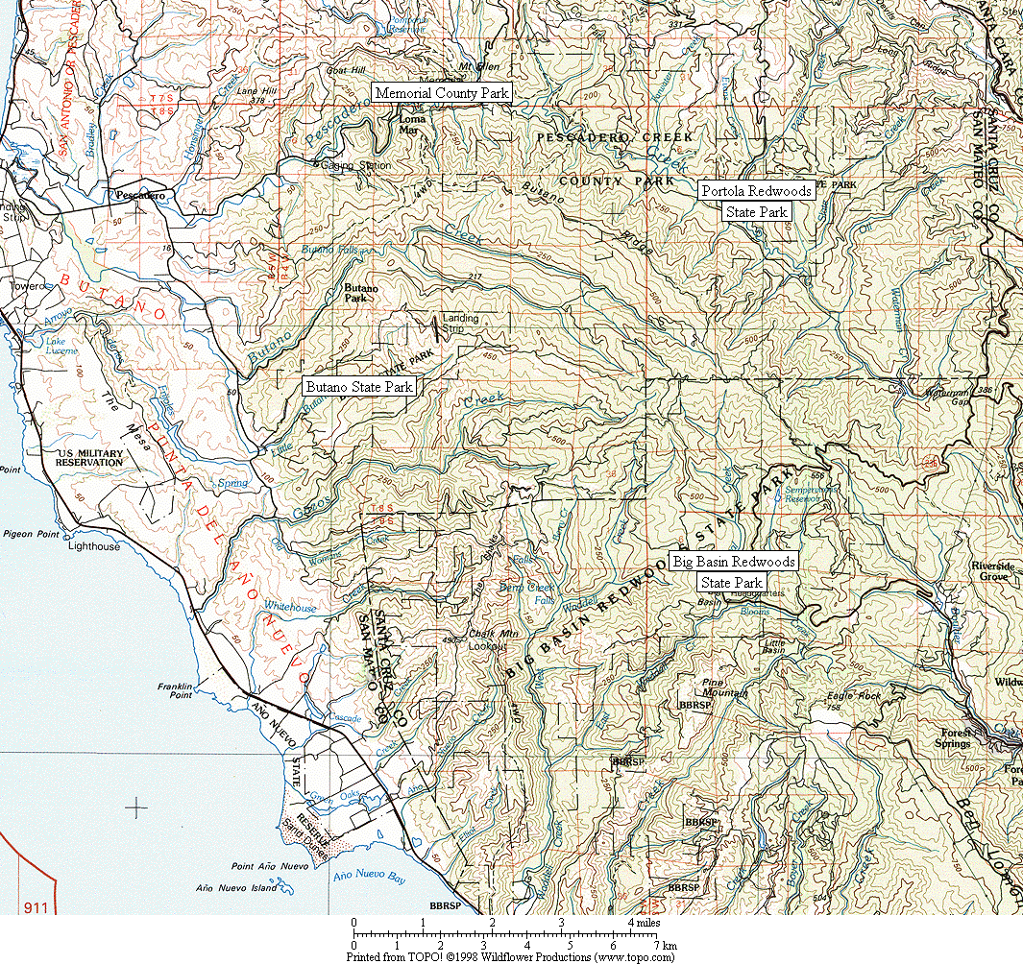

Figure 1. General location of survey areas.

Figure 2. Common Ravens have increased dramatically in all six Christmas Bird Count circles in the Santa Cruz Mountains region. (Note: data presented as a 3-year running mean.)
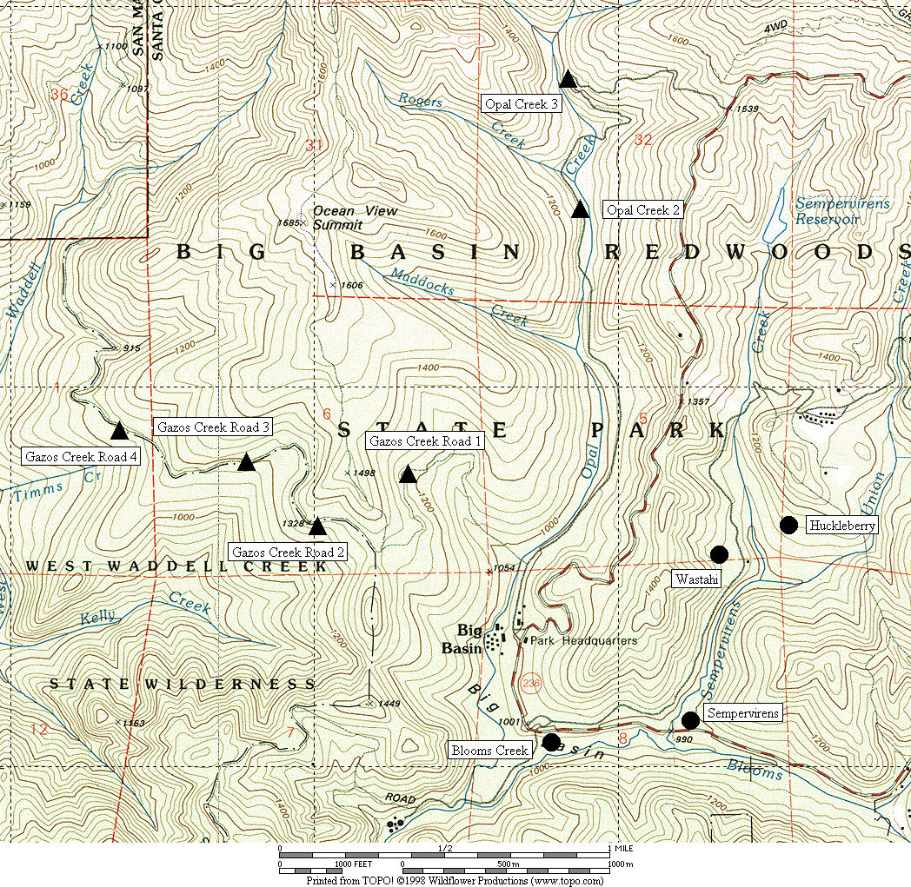

Figure 3. General location of corvid surveys area at Big Basin Redwoods State Park.
● treatment sites ▲ control sites

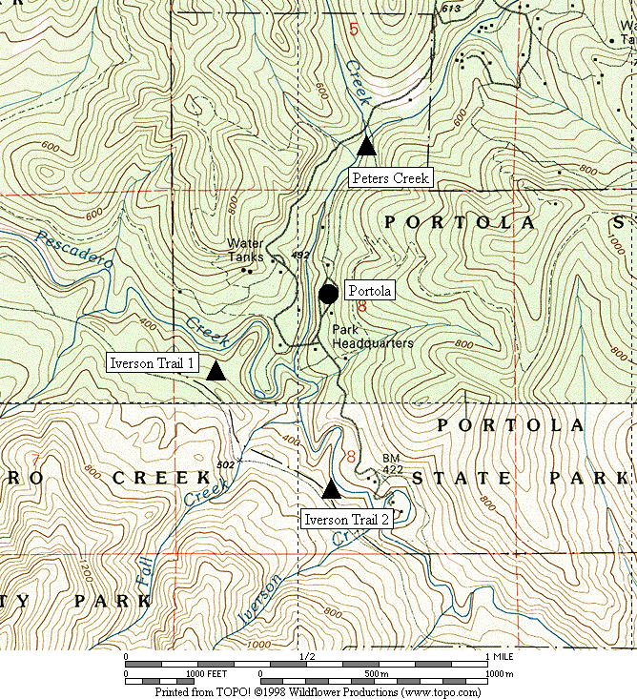

Figure 4. General location of corvid surveys area at Portola Redwoods State Park.
● treatment sites ▲ control sites

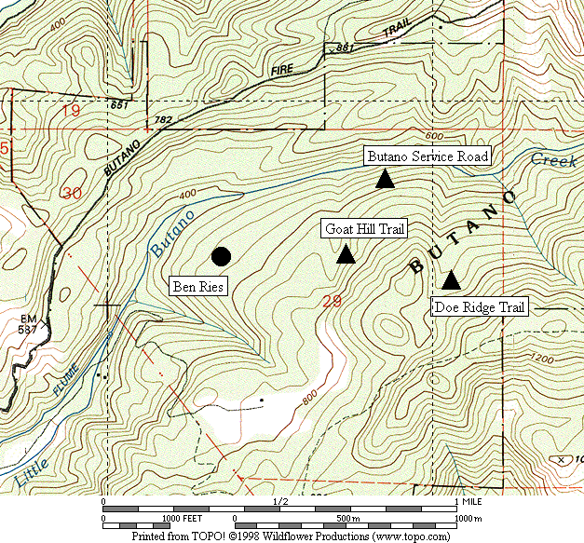

Figure 5. General location of corvid surveys area at Butano State Park.
● treatment sites ▲ control sites

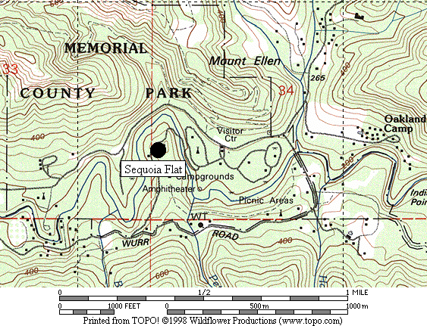

Figure 6. General location of corvid surveys area at San Mateo County Memorial Park.
● treatment sites

Figure 7. Abundance of Steller’s Jay at all sites combined from 2002 to 2004.

A. Big Basin B. Portola

C. Butano D. Memorial

Figure 8. Abundance of Steller’s Jay in each park from 2003 to 2004.

Figure 9. Steller’s Jay density was positively correlated with the number of occupied campsites in 2004.

Figure 10. Juvenile Steller’s Jays increased across the survey period. (Note - on the X-axis: 1 = June 1, 20 = June 20, 40 = July 10, 60 = July 30, 80 = August 19)

Figure 11. The density of Steller’s Jays increased over the season in campgrounds.
(Note - on the X-axis: 1 = June 1, 20 = June 20, 40 = July 10, 60 = July 30, 80 = August 19)

Figure 12. Abundance of Common Raven at all sites combined from 2002 to 2004.

A. Big Basin B. Portola

C. Butano D. Memorial

Figure 13. Abundance of Common Raven in each park from 2003 to 2004.

